# **Computer Hardware Identification**

**Date:**

**Group Name:**

**Group Members (2 Max):**

In this activity, in groups of 2, you will be taking a computer apart. Using a working computer and a phone, take pictures of the components and enter a description of the component and what it does. If the computer that is being dissected does not have the component, then getting an image from the internet is acceptable. Identify and describe the following computer components:

1. Case
   * Image: 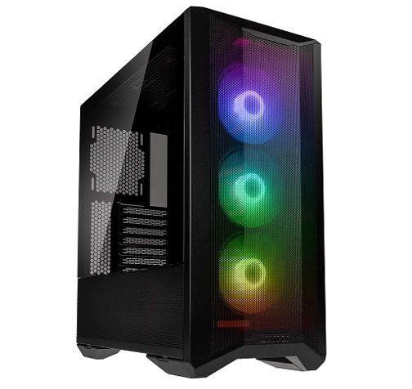
   * Description:it keeps everything tidy, isn’t necessary but your parents wont like tripping over your computer parts if you don’t get one
   * Function:keeps everything organized
2. Motherboard
   * Image: 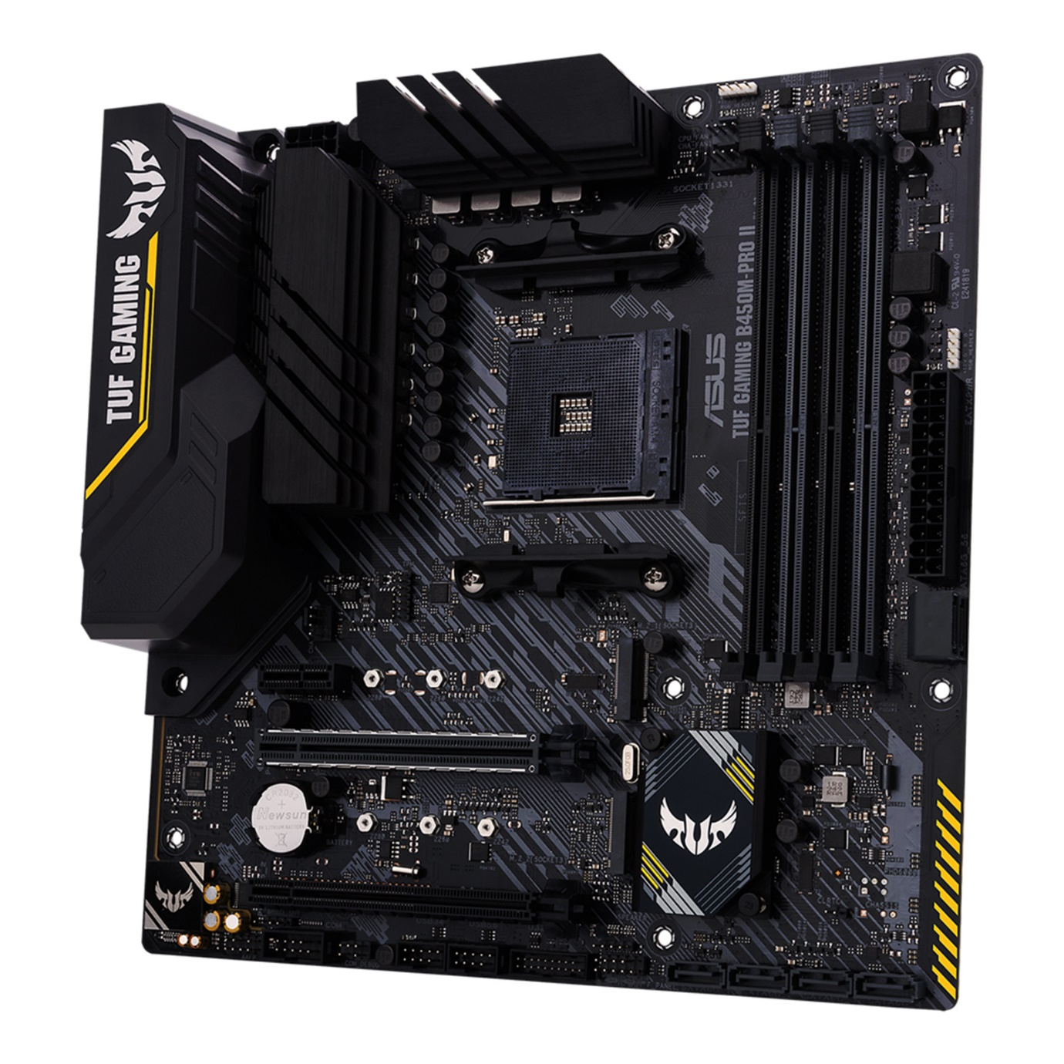
   * Description:basically the centre of the pc
   * Function: connects all the parts together
3. CPU
   * Image: 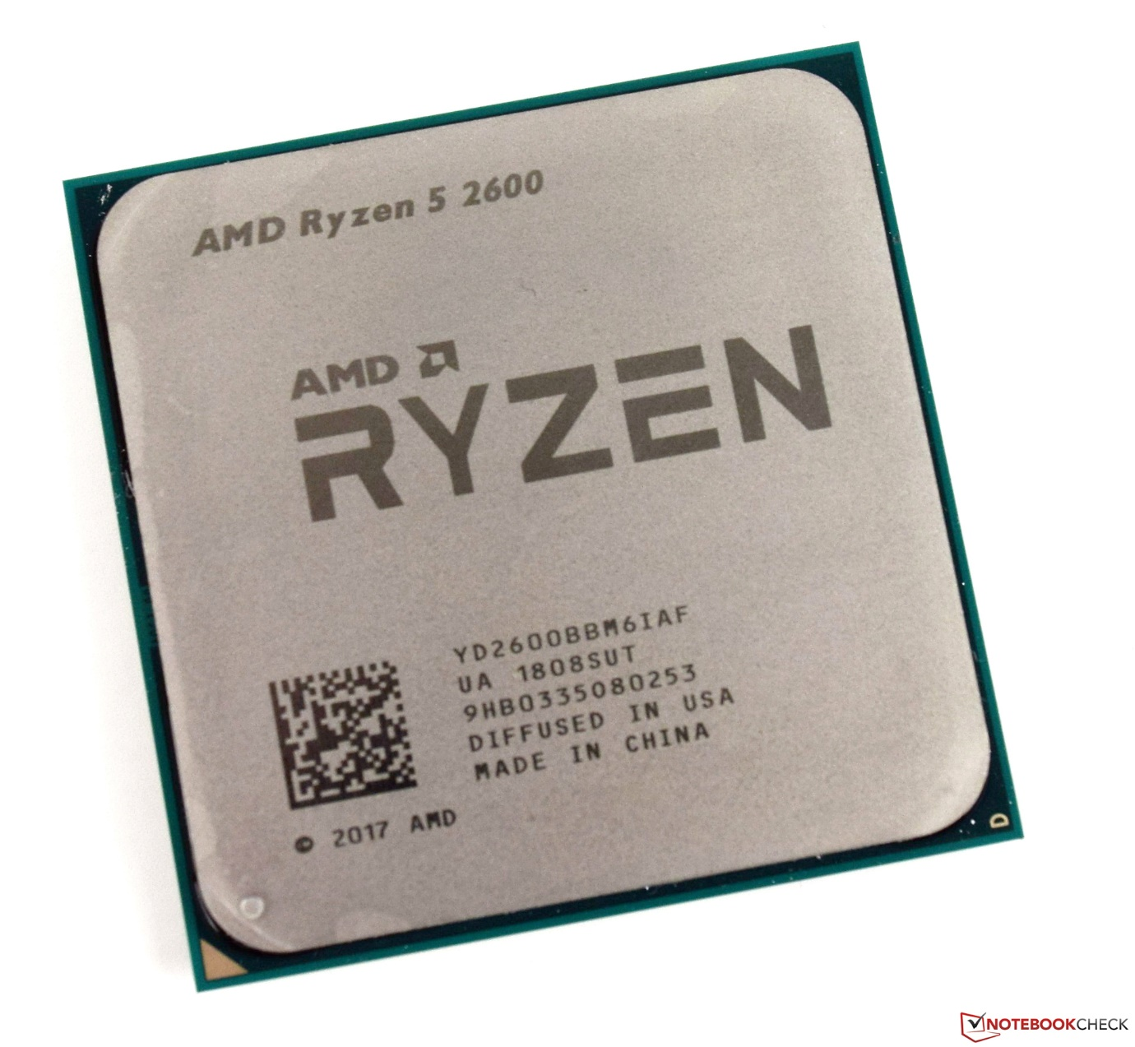
   * Description:it’s the central processing unit
   * Function:does all the processing that isn’t video related.
4. GPU
   * Image: 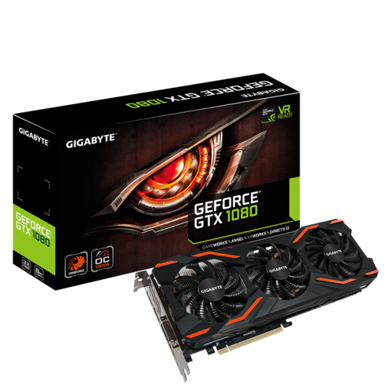
   * Description:handles all video
   * Function:renders all the video output
5. RAM
   * Image: 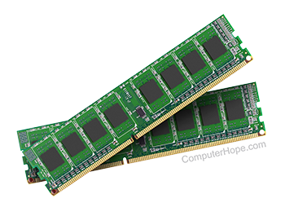
   * Description:
   * Function:keeps all of your progress until you eventually save it in your hard drvie.
6. Storage Device
   * SSD vs HDD
7. Cooling
   * CPU
     1. Image: 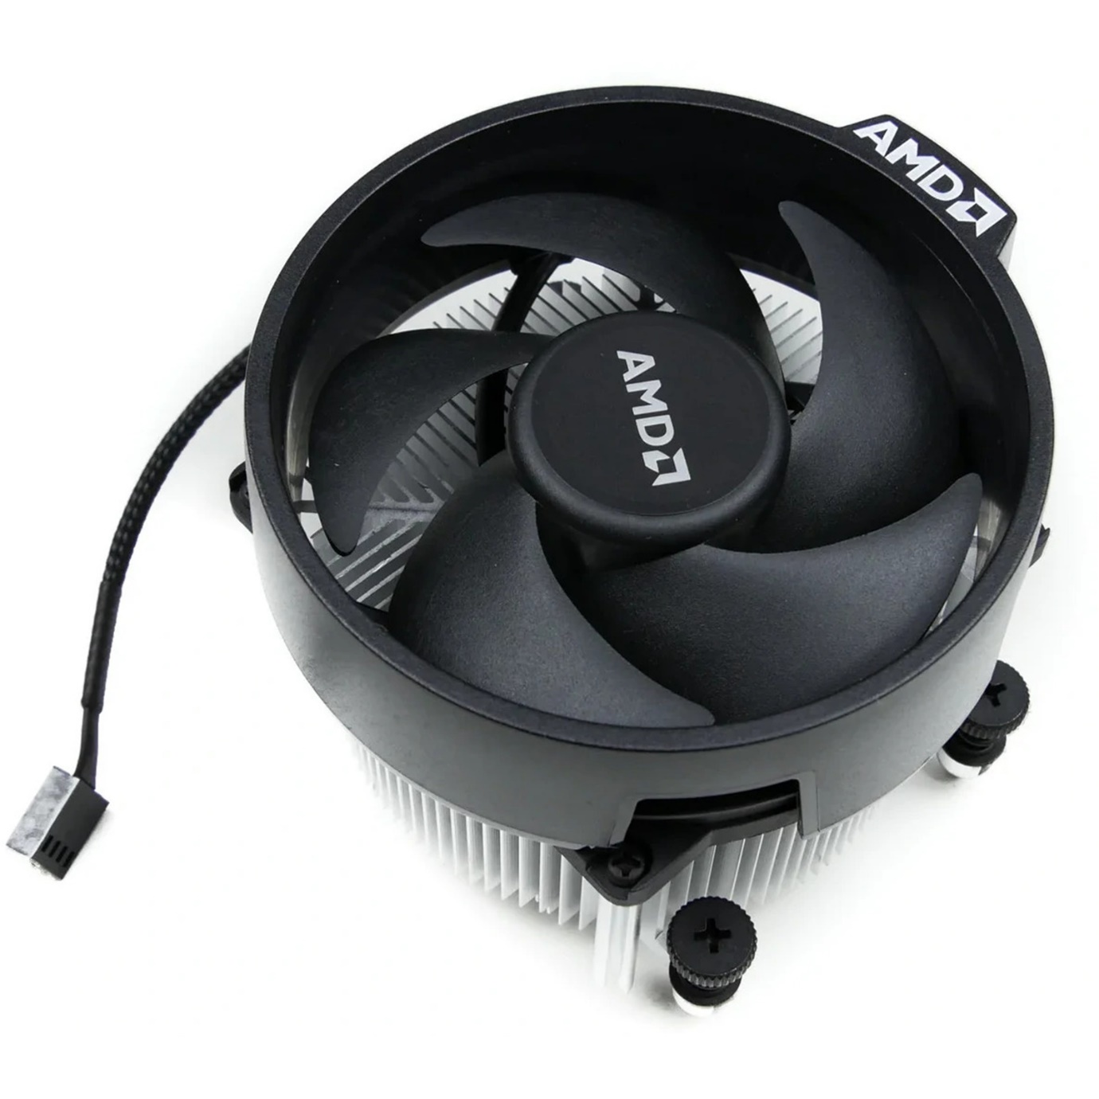
     2. Description:
     3. Function:it keeps the cpu cool
   * Chassis
     1. Image: 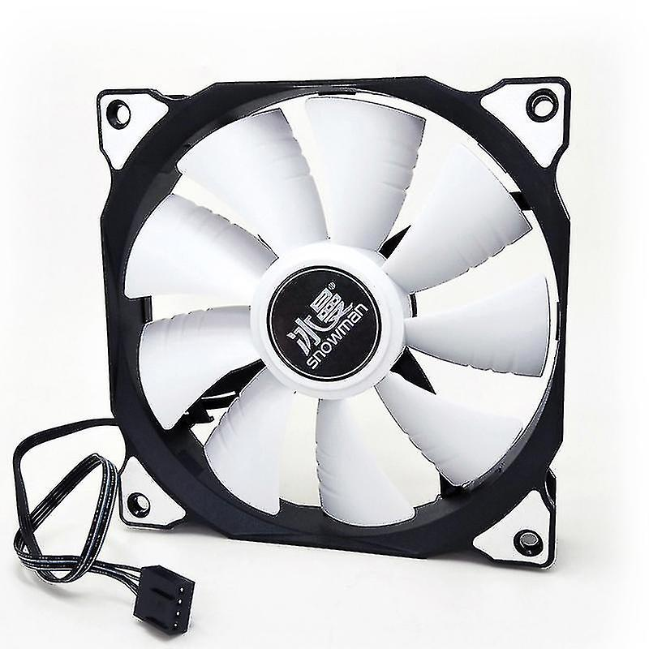
     2. Description:
     3. Function:cools down the pc
8. PSU (Power Supply Unit)
   * Image: 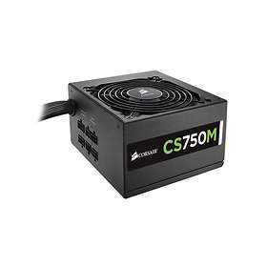
   * Description:
   * Function:keeps all the parts powered
9. Monitor
   * Image:
   * Description:
   * Function:
10. Mouse
    * Image:
    * Description:
    * Function:
11. Keyboard
    * Image:
    * Description:
    * Function: